

Name: Azola Nontyi

Student Number: ST10482076

Lecturer: Andiswa Phewa

Module: Web Development

Table of Contents

Proposal Non-profit Organization -Ubuntu Youth Empowerment 3

1. Organization review 3

2. Website Goals & KPIs 3

3. Current Website Analysis 3

4. Proposed Features 3

5. Design Aesthetic 4

6. Technical Requirements 4

7. Timeline with Milestones 4

8. Budget: Realistic Cost Estimation. 4

# Proposal Non-profit Organization -Ubuntu Youth Empowerment

## 1. Organization review

The name of the organisation that I chose is Ubuntu Youth Foundation. (United Nations Development Programme. (2020). Youth empowerment for suitable development)

The history of the organisation, it was found in Cape Town, which it provides educational resources and tutoring to the youth that are disadvantaged in South Africa. (Mkhize, T., & Naidoo, P. (2020)

The mission and vision are to power the youth’s knowledge, skills, communication skills, problem solving and critical thinking basic literacy and numeracy.

The target audience is the youth that are aged between 16-30, which are full of potential, mentally and physically fit. (Mkhize, T., & Naidoo, P. (2020)

## 2. Website Goals & KPIs

The goal is to increase the organization programs, donor contributions and to provide resources to the stakeholders and beneficiaries, they also assist participant sign-ups and contributors. (Nelson Mandela Foundation. (2021). Youth leadership and empowerment programmes).

The KPIs increase 30 percent in the traffic of websites which it increases six months. The registration increases twenty percent within three months, and the growth of the online donors increases twenty five percent yearly. (Statics South Africa. (2021). Quarterly labour force survey:

## 3. Current Website Analysis

The Ubuntu youth empowerment depends in social media, so it needs a dedicated website, because they rely on social media which limits their potential to sponsors and donor trust.

## 4. Proposed Features

Homepage: Is the overview of the Ubuntu youth empowerment their stories, goals, calls to action and their development.

* **About us**: Is the values of the empowerment, history and the profile of the people in the organisation.
* Programs: Is the upcoming events and information academic support, skill development, entrepreneurship programs and internship programs.
* **Get involved**: Participate actively, by embracing your experience or knowledge, participate with other people, promote to the community and build your skills.
* **Resources**: Is the training and professional development, addressing the organizations need and strengthening the organizations resources, educational necessaries and partners from the community to support one another,
* **Contact**: To contact the organization, its either you call them, go to their website or you can go to them using their address and you can also email them.

## 5. Design Aesthetic

* **Colour Scheme:** They must use warm colours, like orange, yellow to attract their attention
* **Typography:** The fonts must be readable not to big but also not to small just a reasonable size.
* **Layout:** The layout must be user friendly and perfectly designed.
* **Wireframes:**

## 6. Technical Requirements

* **Hosting**: They host 99,9% of the time
* **Domain**: They must have a secure registration (e.g. [www.ubuntuyouth.org](http://www.ubuntuyouth.org))
* **Development**: They should use JavaScript, WordPress, Html, CSS3 to make their content governing.

## 7. Timeline with Milestones

* **1 Week**: Gather as a team and see who is going to do which task and everyone should start doing their task
* **2-3 Week:** Plan ideas and approval
* **4-6Week:** Create and combine ordering structure
* **7 Week:** Fix errors and bugs to see whether it runs
* **8 Week:** Set up a meeting and staff coaching.

## 8. Budget: Realistic Cost Estimation.

**Plan & development:** R36,000

**Integration:** R 15,000

**Event plan:** R5,000

**Maintenance:** R7,000

**Total:** R63,000

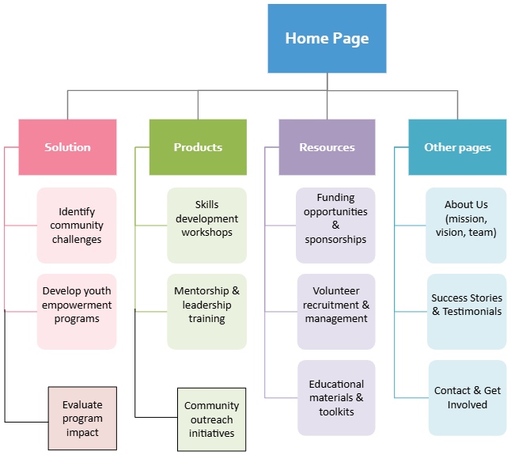

**Reference list**

Kotler, P. & Keller, K.L.,2016. Marketing Management. 15th ed. Pearson.

Krug, S., 2014. Don’t Make me Think. 3rd ed. New Riders.

African Union. (2022). African youth charter. African Union Commission.

World Economic Forum. (2022). Future of jobs report 2022. World Economic Forum.

Nelson Mandela Foundation. (2021). Youth leadership and empowerment programmes.

United Nations Development Programme. (2020). Youth empowerment for sustainable development. United Nations.

Nations Educational, Scientific and Cultural Organization

Kekana, M., & Letsoalo, P. (2022). Non-profit organisations and community development in South Africa: Challenges and opportunities. Journal of Contemporary African Studies, 40(3), 367–384.